Step by step – Data gathering and transformation

1. Get resource data from an Excel spreadsheet.

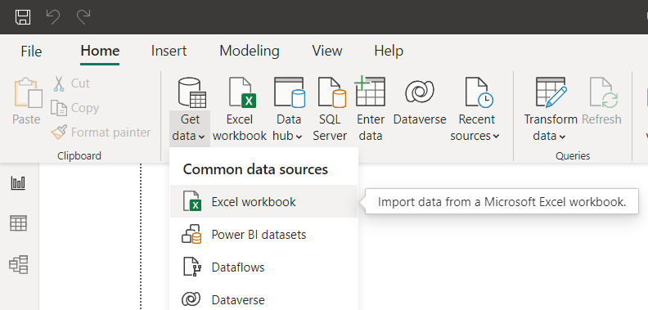

1. When we choose Excel Data from the file. The navigator will appear as shown below.

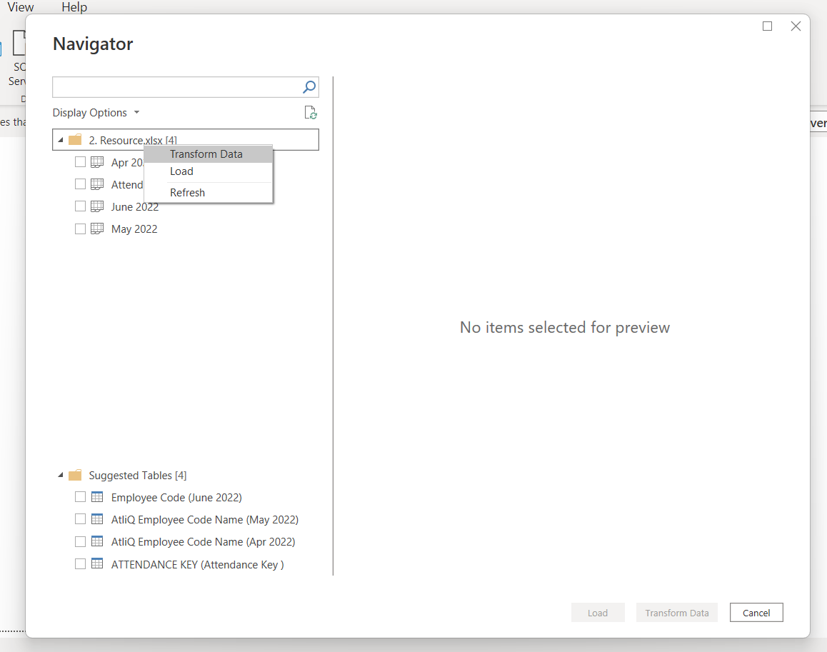

1. Right click on the folder and select “transform data”.
2. 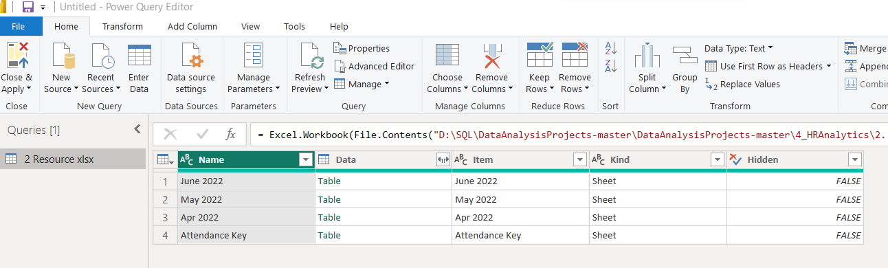When we click that, a new tab will open which is a power query editor.
3. 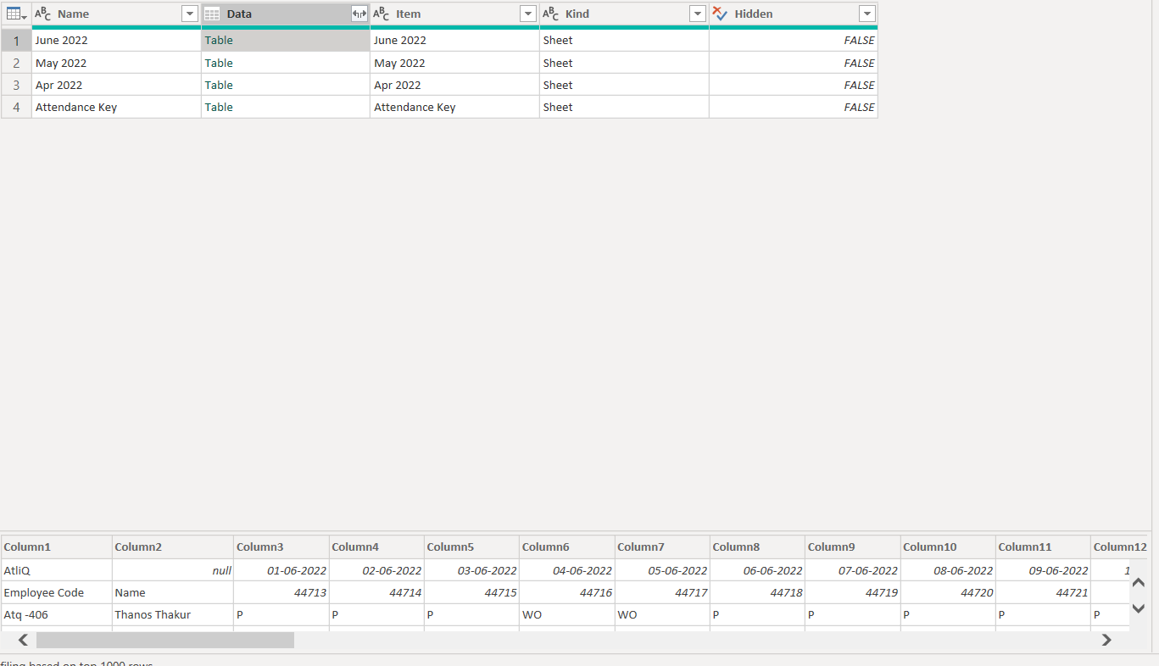Select data column, we will see that particular sheet data below as shown in the image.
4. 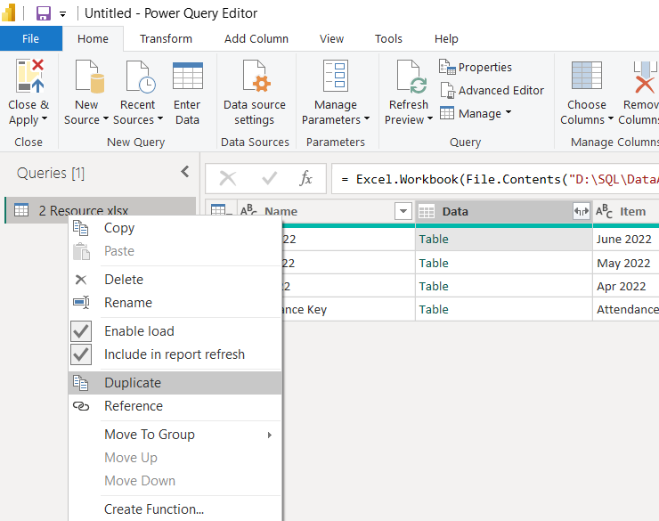We need to duplicate the folder so that we do not have to clean every sheet, and if we add another month's data, it will clean itself. We'll need to create a template for that.
5. Then select he rename option and rename it as “template”

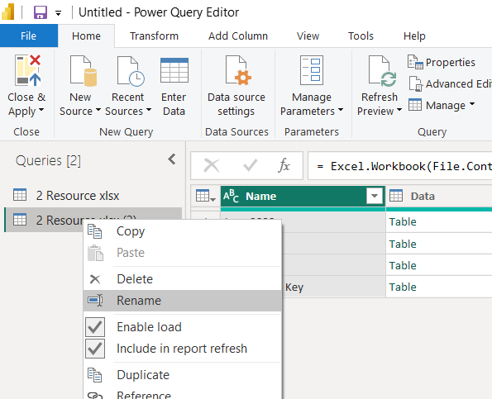

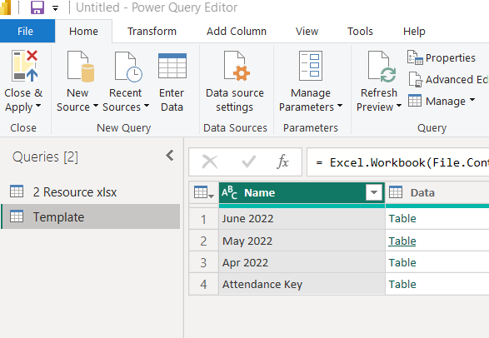

DATA CLEANING

1. We do not need “attendance key” sheet, it is just for internal reference.

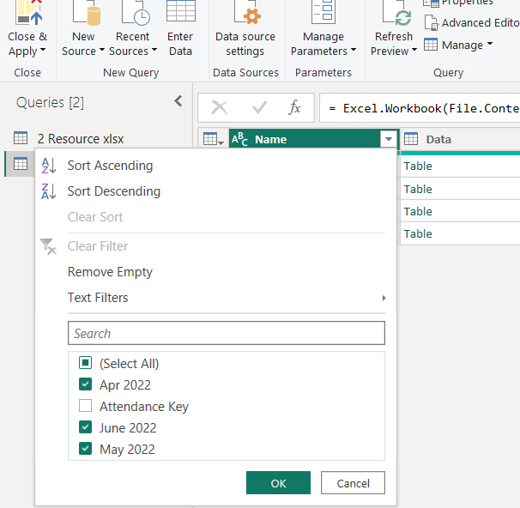

1. We will select one particular sheet, let say we select April sheet, and the we are going to apply the transformation in one sheet and then its replicate the rest of the sheets.

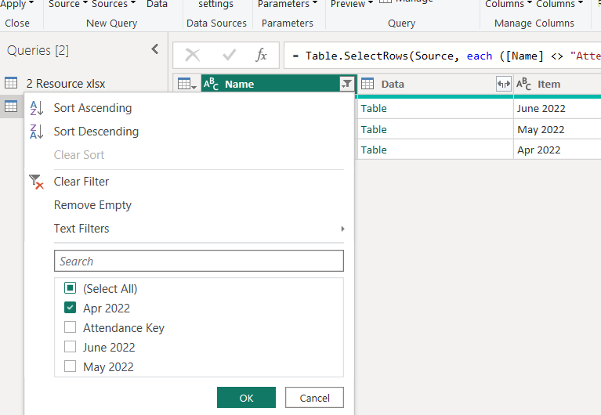

1. 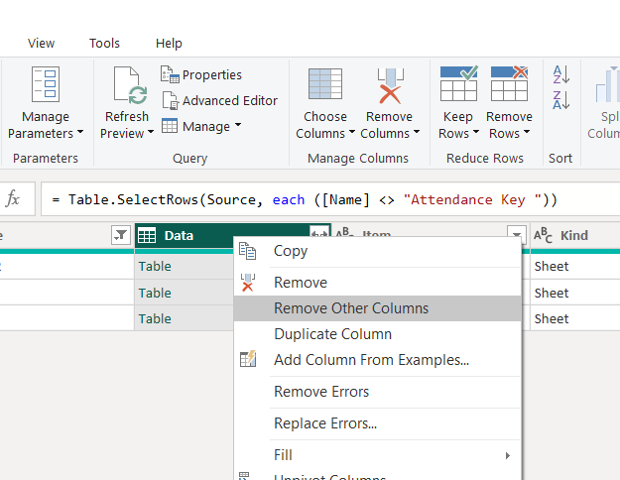We need to keep only the data column, rest can remove. Right-click on the column to make the column transformation appear.
2. This is table in which we have all the data.

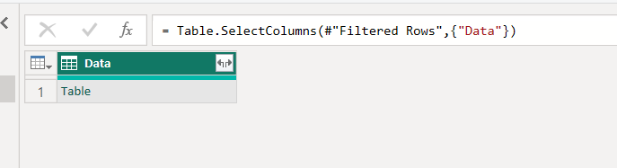

1. 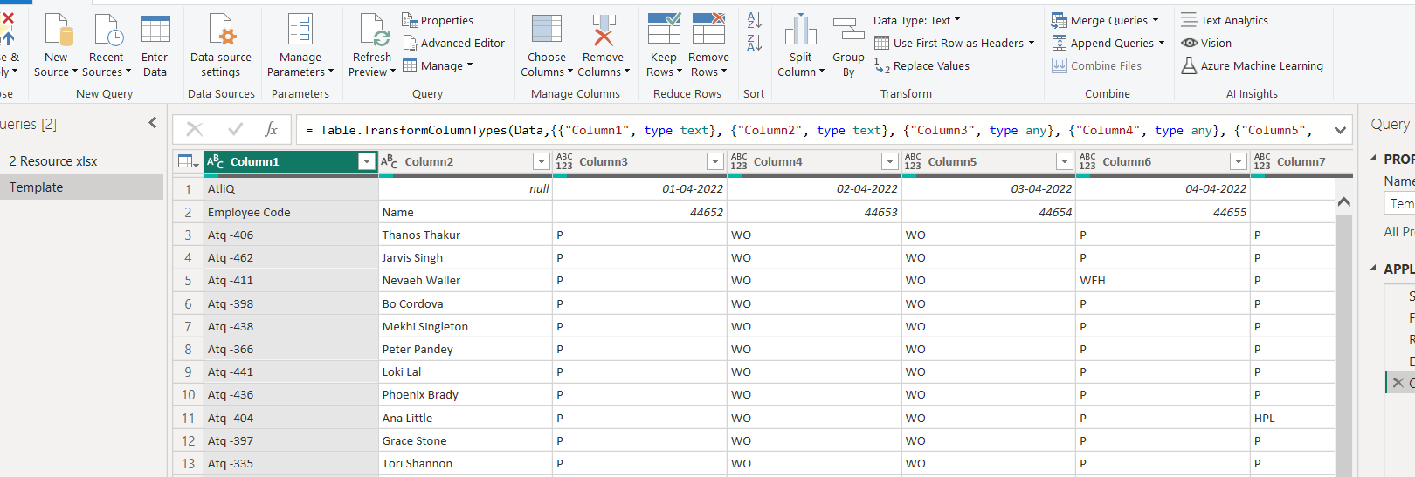We will be going to expand this table sheet. And it will be exactly as excel file which shows below.
2. 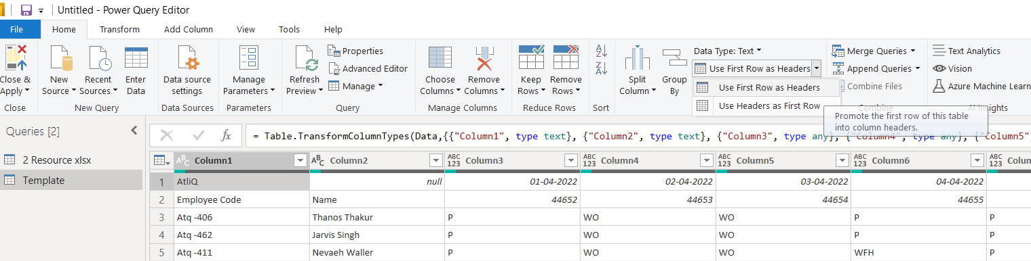We need add first row as header.



1. We need to remove first row now, as we do not need that anymore.

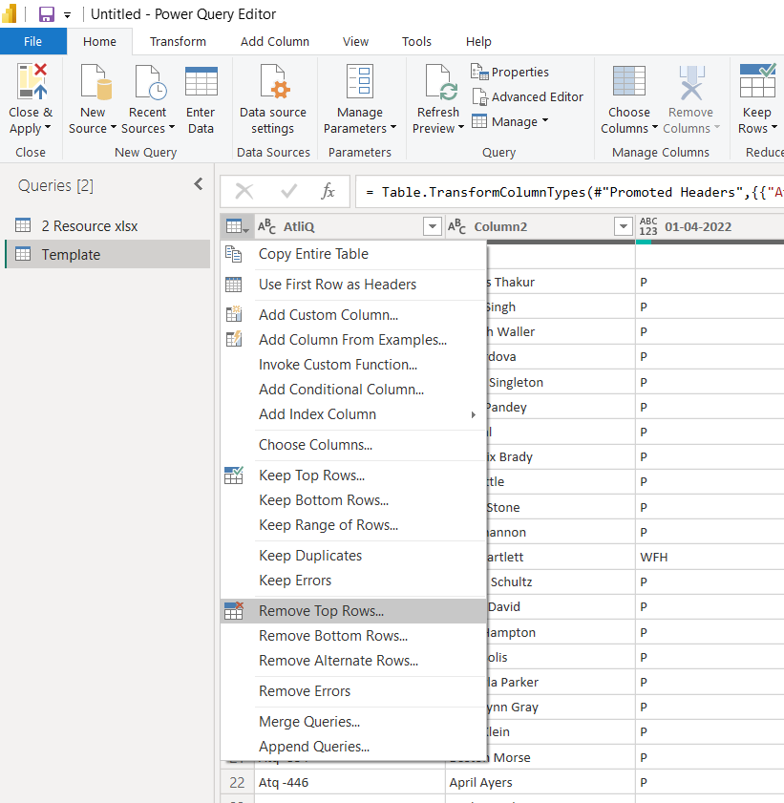

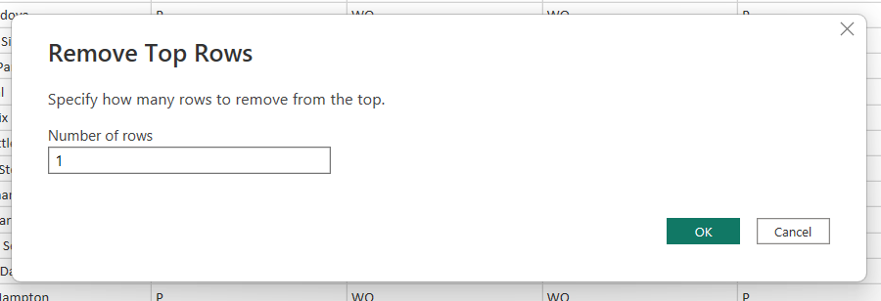

1. 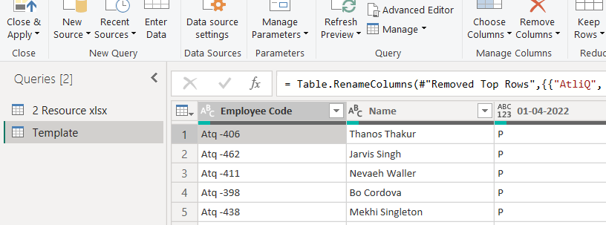Need to change column names.
2. Apart from the first 2 columns, everything is the date columns.

We want the dates which are in column separated, should be in one column.

For that we need to transform the data with transform menu.

In Excel we have transpose option. In power bi editor , we use unpivot column.

As we need to transpose the dates separated columns into one column.

1. 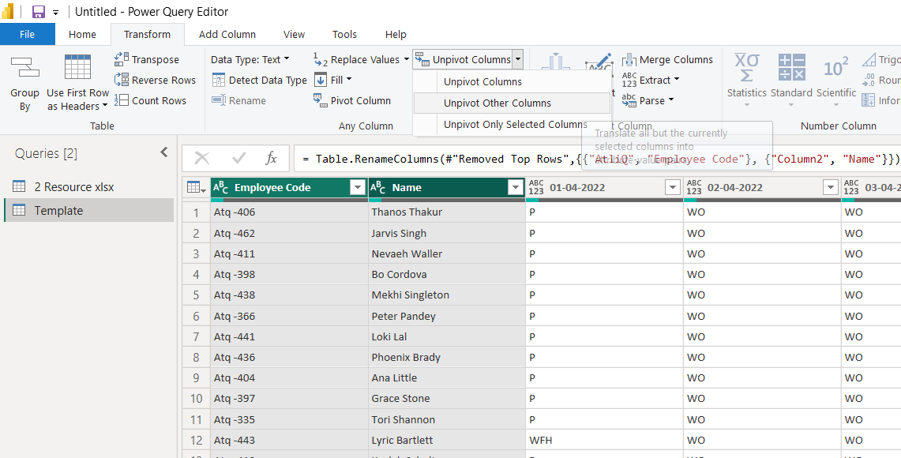we need to select the columns which don’t need to unpivot.
2. Go to transform menu, select unpivot column, in that select unpivot other columns.

1. 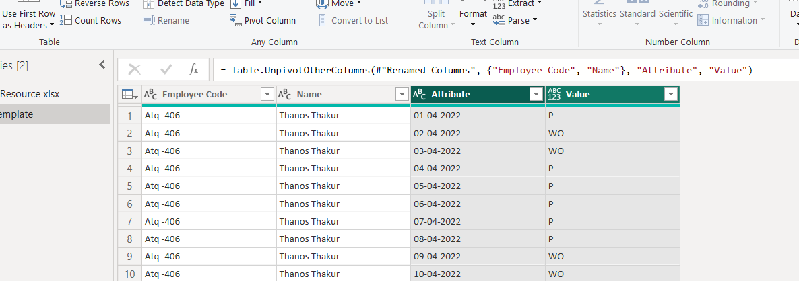We will see the result as below.
2. 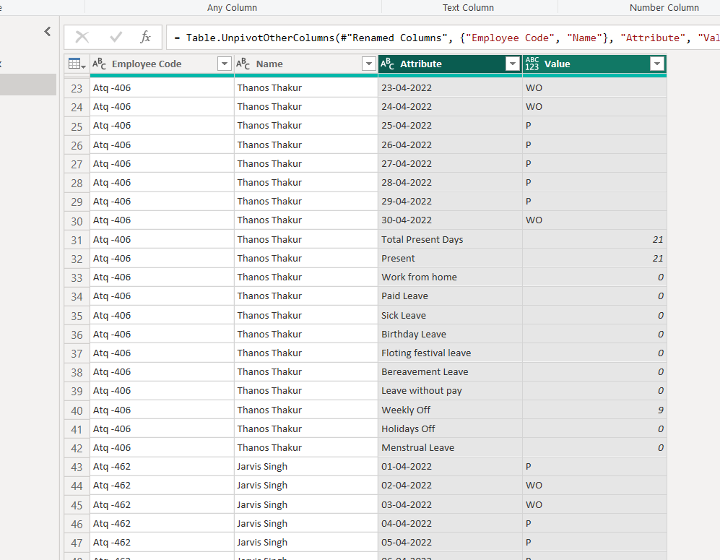As discussed in the 9th point. We thought except first 2 columns, everything is dates column. But we have few other columns, which are not dates. As shown below.
3. To remove those texts, we need to change the data type as “Date”. So that except dates, everything shows as an error. Shown in below image.

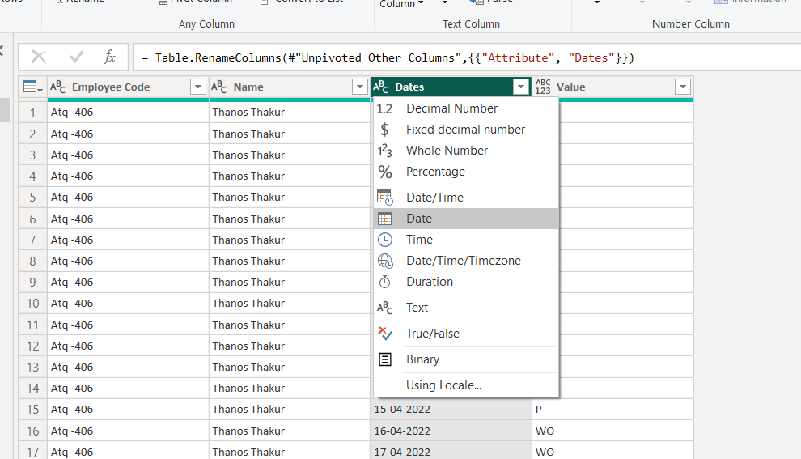

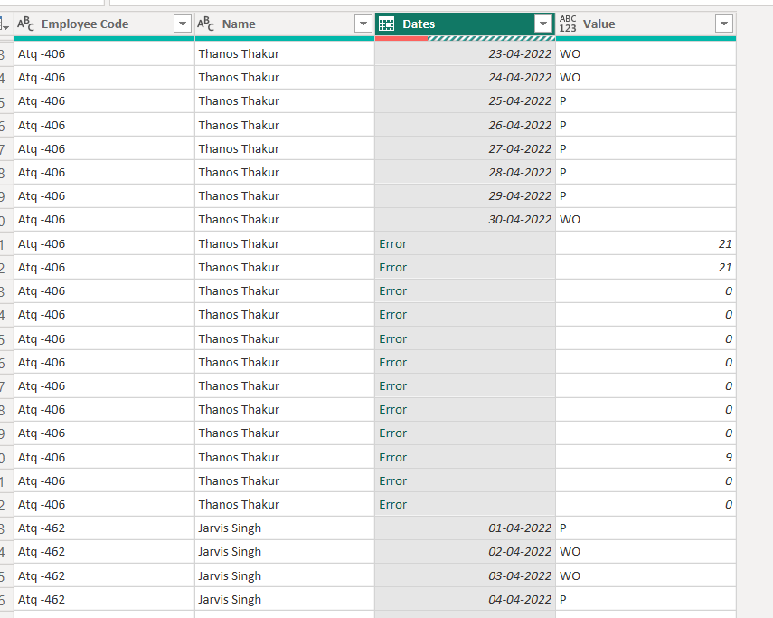

1. 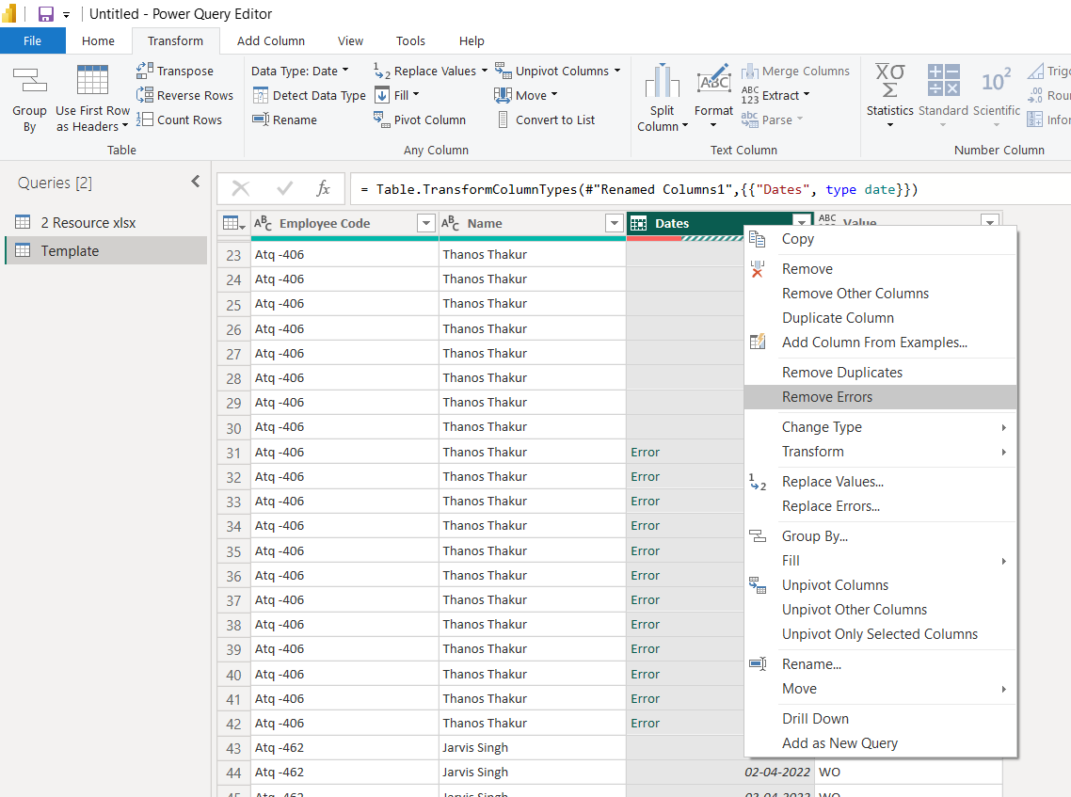Right click the column and select the remove errors.
2. We need to create a parameter.

Let say every month if we need particular day, parameter is a way of filtering that particular day and this can be dynamically change.

1. 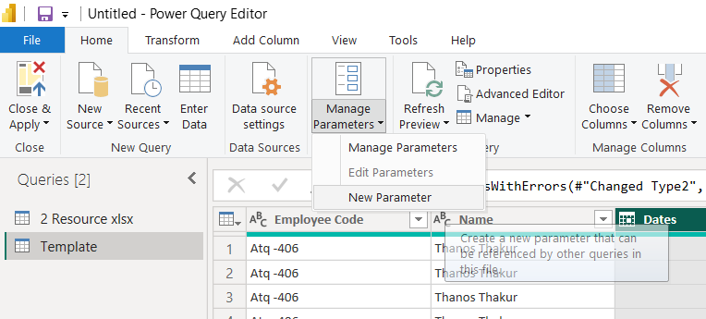In Home menu, select Manage parameter 🡪 new parameter

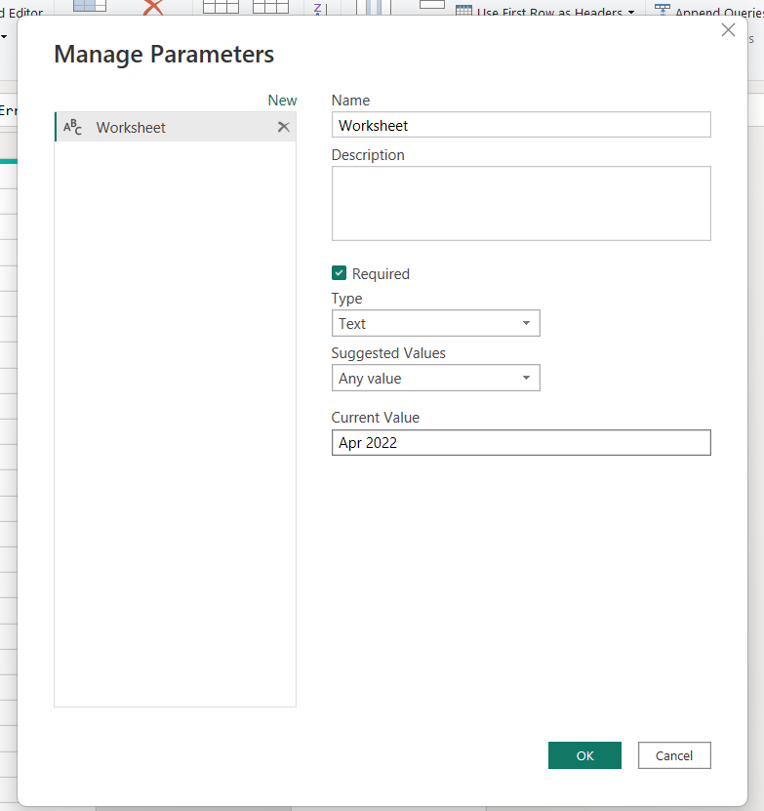

Write the sheet name, which we modified

Change the Type to Text

Change the name as worksheet

1. 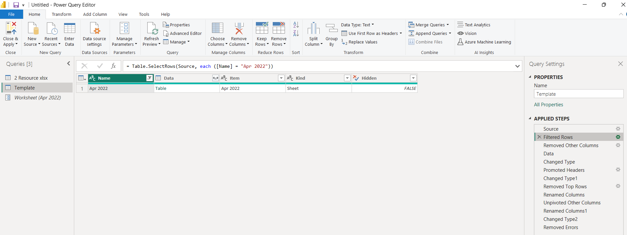We need to place parameter filtered row which is hard coded shown in below image.
2. Click filtered row setting

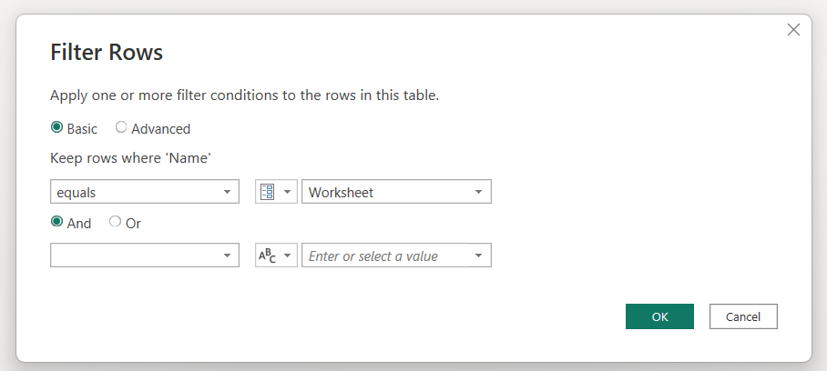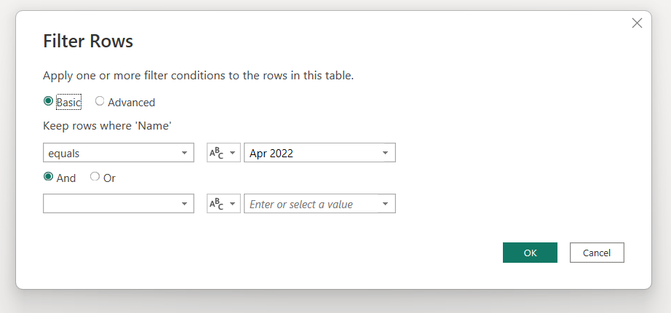

1. Now we will apply this transformation to all the sheets.

For that we need to create this as a function. For the reusability of the steps.

1. Right-click on the “template” and select “create function”

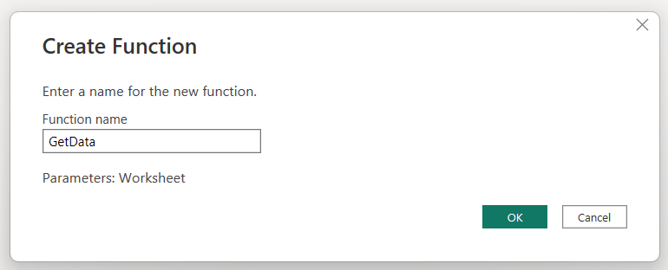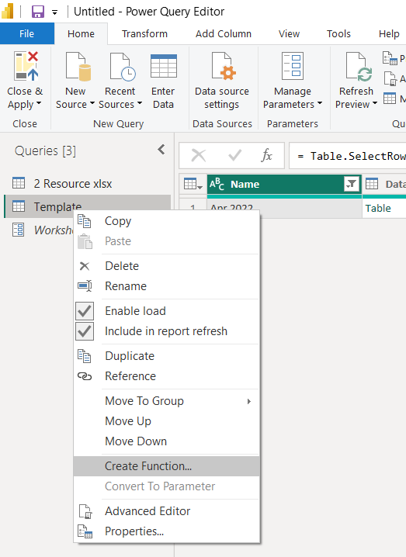

1. We have to move to original file. i.e., “Resouces” and filter the attendance key sheet.

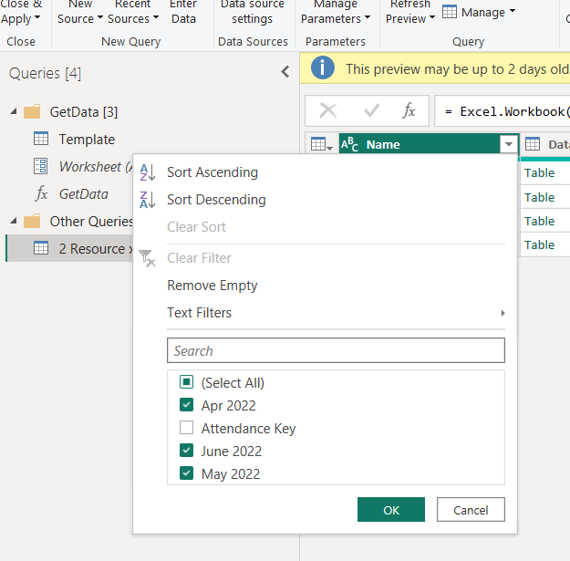

1. We have to add the function as a column. For that “Add Column” menu and then “Invoke Custom Column”.

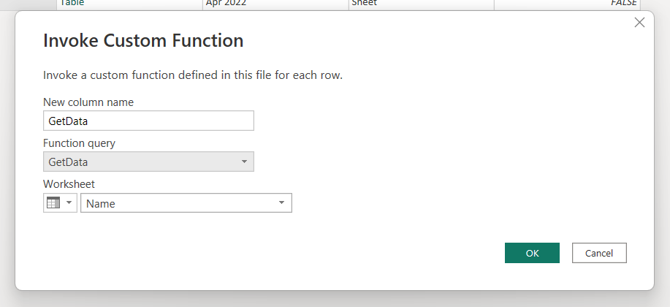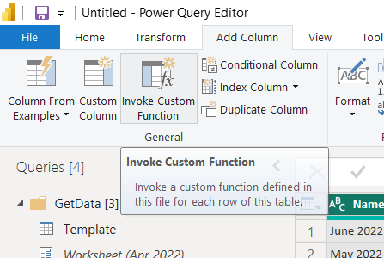

1. 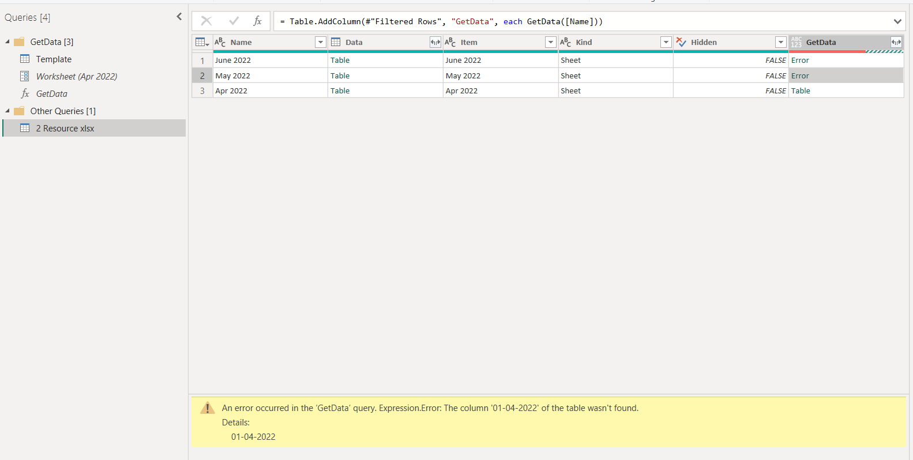We found error on may and june sheet as shown below.

This function is trying to reference a column, we need to delete all the steps which tries reference the column. Here above image, it is seeing 1st of April in may data, and it won’t find it.

1. 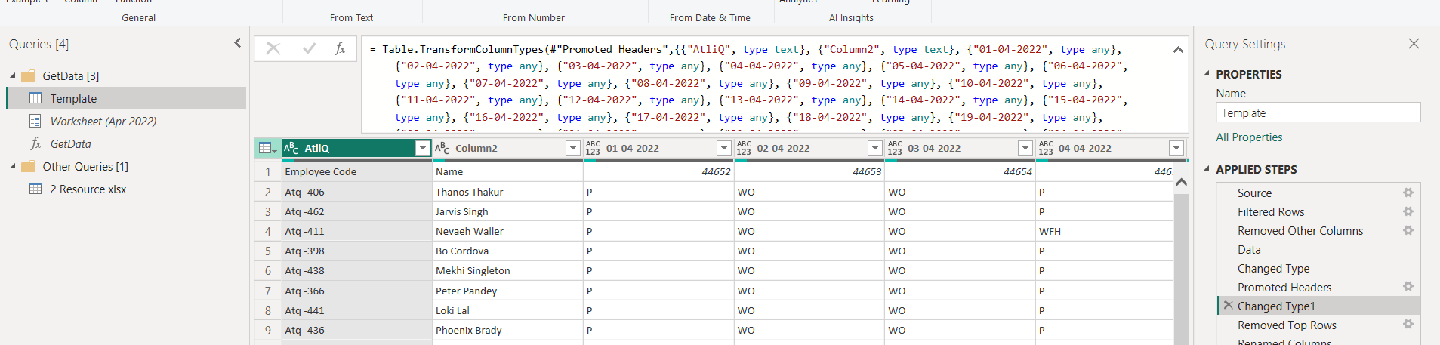We will go to Template and then remove the reference column(delete the step).

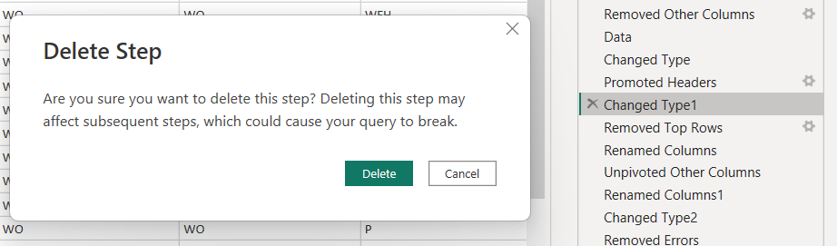

1. 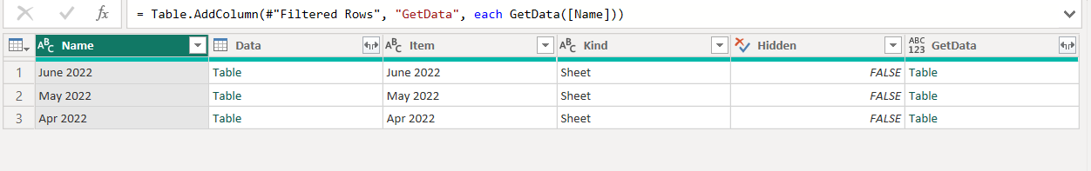Now it is clear, in the function
2. We need to expand the table. Uncheck “Use original column name as prefix” to keep column name as short.

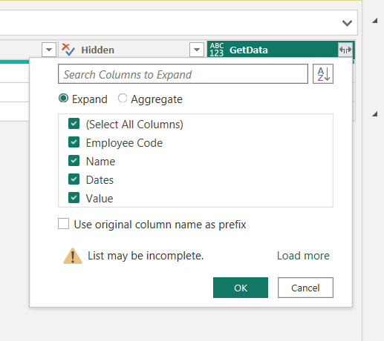

1. Remove unwanted columns.

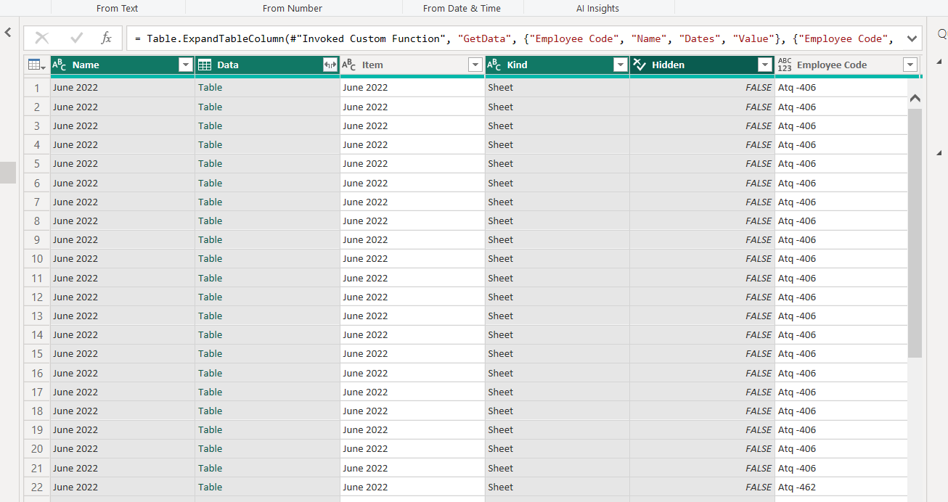

1. Change the heading names and change the types

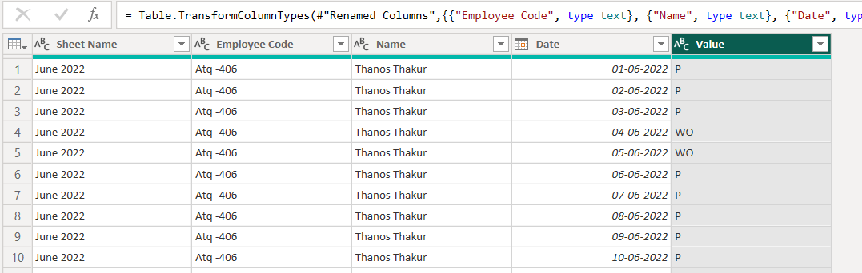And double check whether it is clean, good.

1. Change the name of the sheet as “Final Data”. And then click Apply & Load.

